RESOLUTION NO.__________

RE: CERTIFICATE OF APPROPRIATENESS UNDER THE
PROVISIONS OF THE ACT OF THE PENNSYLVANIA
LEGISLATURE 1961, JUNE 13, P.L. 282 (53
SECTION 8004) AND BETHLEHEM ORDINANCE NO.
3952 AS AMENDED.

WHEREAS, it is proposed to install a new sign and window signs at 11 E Third Street.

NOW, THEREFORE, BE IT RESOLVED by the Council of the City of Bethlehem that a Certificate of Appropriateness is hereby granted for the work.

Sponsored by: (s)

(s)

ADOPTED BY COUNCIL THIS DAY OF

(s)
President of Council

ATTEST:

(s)
City Clerk

HISTORIC CONSERVATION COMMISSION

CASE # 572– It is proposed to install a new sign and window signs at 11 E Third Street
OWNER/APPLICANT: Shale Road LP / Signarama-Lehigh Valley

The Commission upon motion by Mr. Cornish seconded by Mr. Evans adopted the proposal that City Council issue a Certificate of Appropriateness for the proposed work described herein:
The proposal to install a new sign and window signs at 11 E Third Street was presented by Steve Stigliano from Signarama.
The sign will be retro fitted into the existing sign structure which is 114” x 29”
The sign will read “edible arrangements” in red lettering with multicolor logo on a brushed silver aluminum face.
The logo will be flat vinyl and the text will be “pushed through” the metal face and backlit. A red, ½” pin stripe border located approximately 1 ½” from the edge will be added to the sign.
The proposed window signs for above the door (24” x 8.9”) and on the two side glass panels (32” x 11.9”) will have the same graphics, all in vinyl.
A revised drawing will be submitted to the Historic Officer for review before permitting and installation.
The proposed motion was unanimously approved.

CU: cu
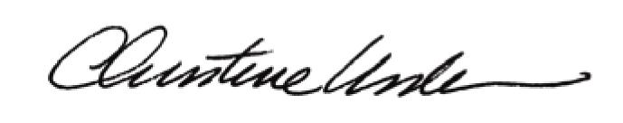

By:

Date of Meeting: December 21, 2015 Title: Historic Officer

